Restaurants in Liverpool

Paul’s German Restaurant and Bake Shop
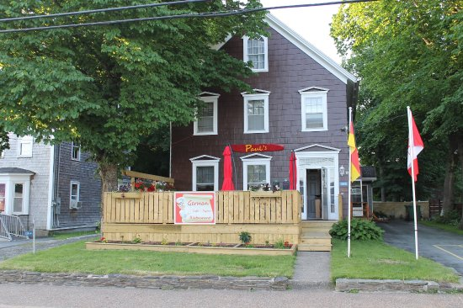
343 Main Street, Liverpool – 902-356-3155
www.sable-river-camp.com
Sunday - 9:00 AM – 4:00 PM
Monday – 9:00 AM – 3:00 PM
Tuesday – 9:00 AM – 6:00 PM
Wednesday – 9:00 AM – 6 PM
Thursday – 9:00 AM – 6:00 PM
Friday – 9:00 AM – 8:00 PM
Saturday – 9:00 AM – 8:00 PM
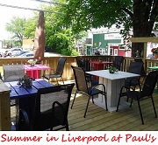
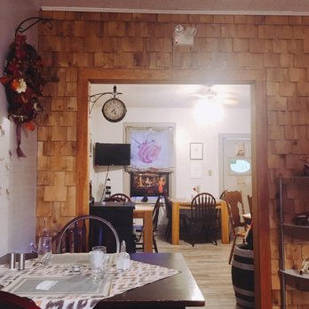

Lane’s Privateer Inn
27 Bristol Avenue – 902-354-3456
www.lanesprivateerinn.com
Fine Dining, Casual, Licensed, Seafood, Gluten Free
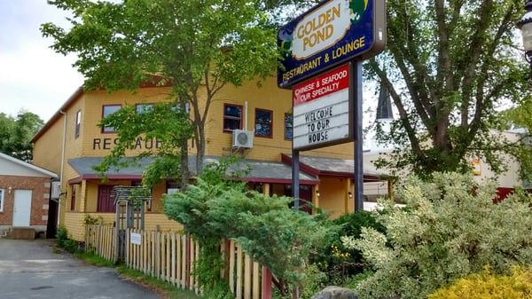
Golden Pond Restaurant
73 Henry Hensey Drive
902-354-5186
www.thegoldenpond.net
Licensed

Liverpool Pizzeria - 155 Main Street – 902-354-2422
Licensed, Casual
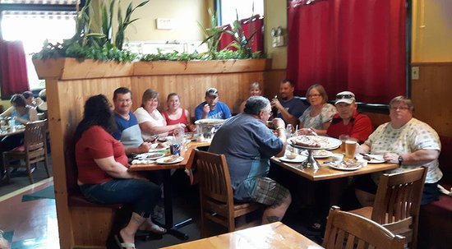
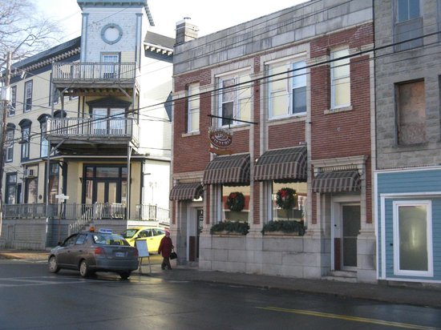

Memories Café & Eatery
28 Water Street, Waterfront Plaza - 902-356-3110
Licensed, Gluten Free, Café
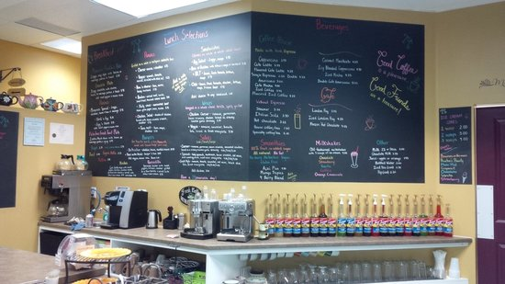
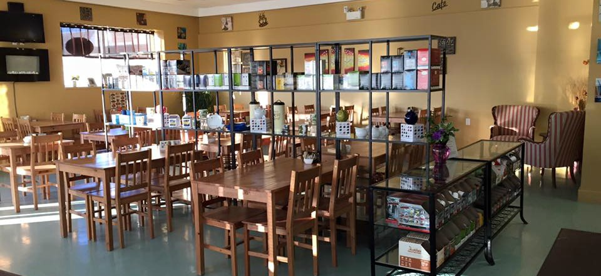
Motel Transcotia
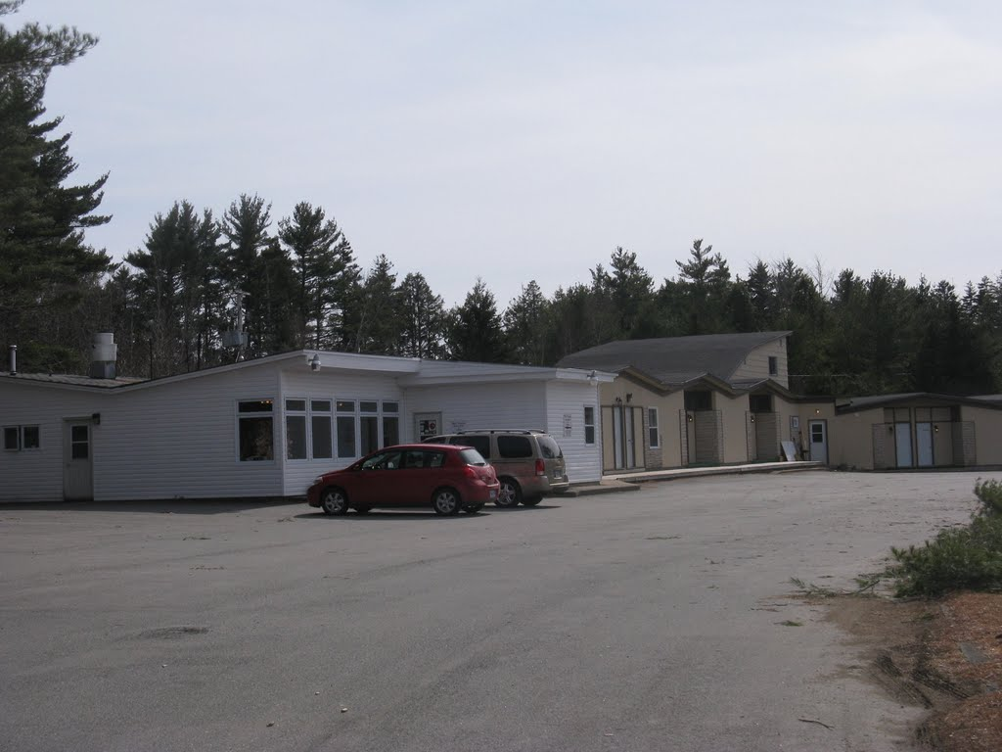
3457 Highway #3, Brooklyn
902-354-3494
Licensed, Casual, Seafood

Tim Hortons
170 Bristol Avenue
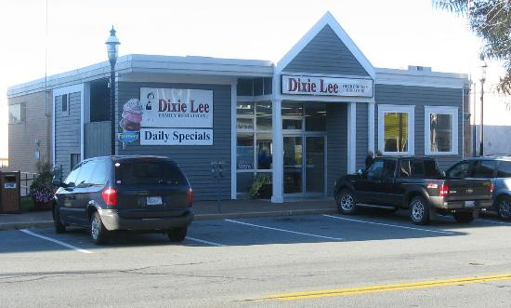
902-354-2719

Dixie Lee Family Restaurant
254 Main Street - 902-354-3030
Casual, Seafood

Subway
25 Milton Road - 902-354-7358
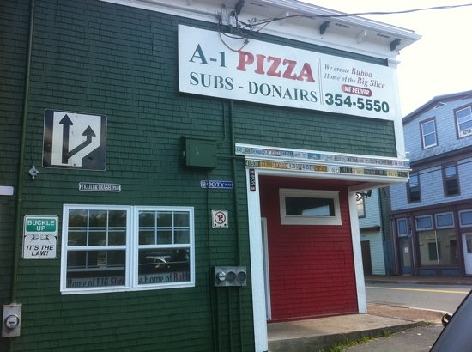

McDonald’s
203 Bristol Avenue - 902-354-5150

A-1 Pizza
332 Main Street - 902-354-5550

Oscar’s Liverpool Flowers, Gifts and Restaurant
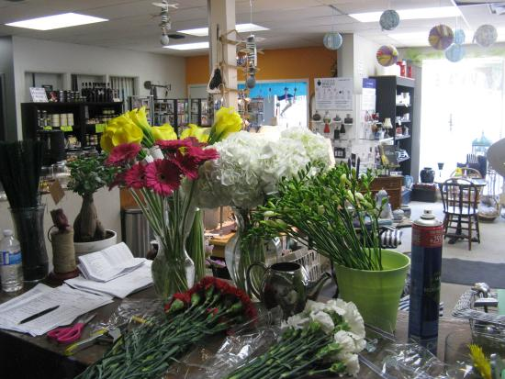
154 Main Street - 902-356-6677
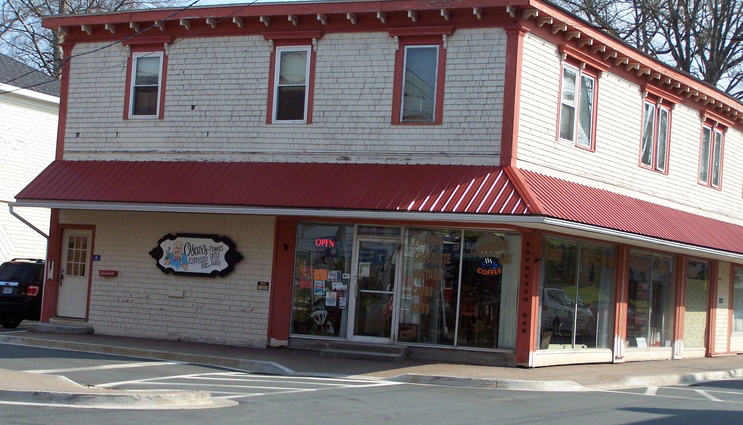

Outside of Liverpool
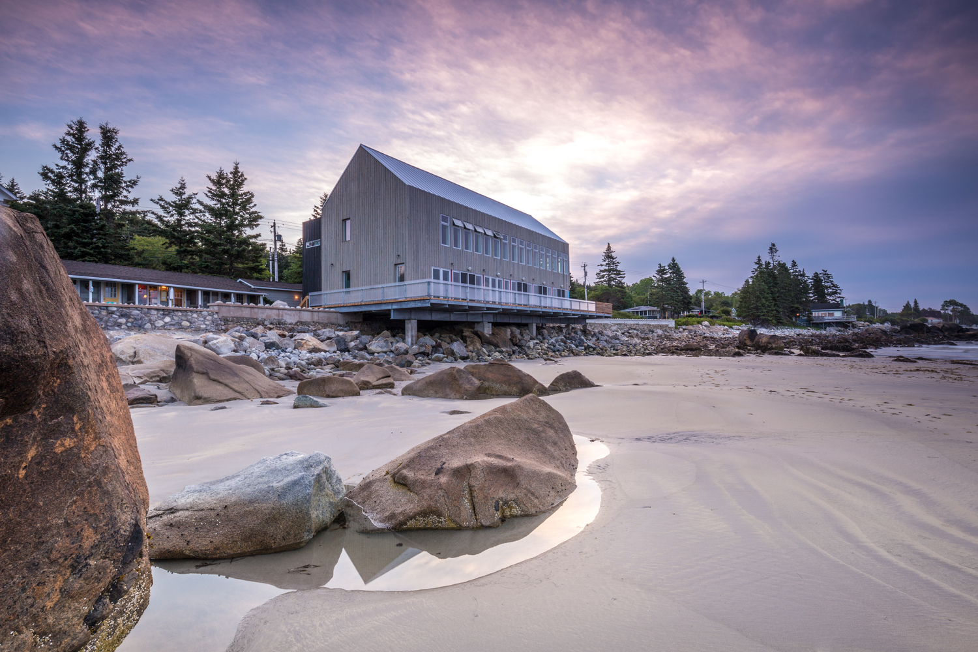
Quarterdeck Beachside
Villa & Grill
7499 Route #3, Port Mouton (Summerville Beach) – Exit 20
902-947-2050 – Reservations Required
www.quarterdeck.ns.ca
Fine Dining, Seasonal, Casual, Seafood
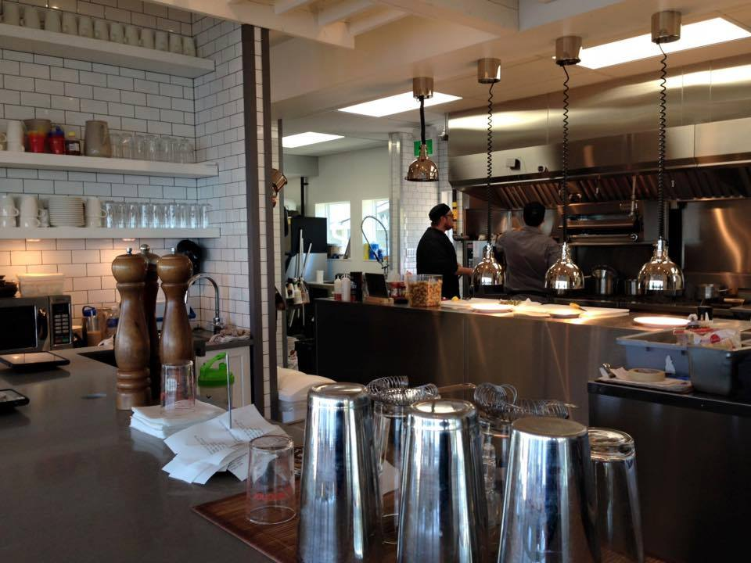
White Point Beach Resort
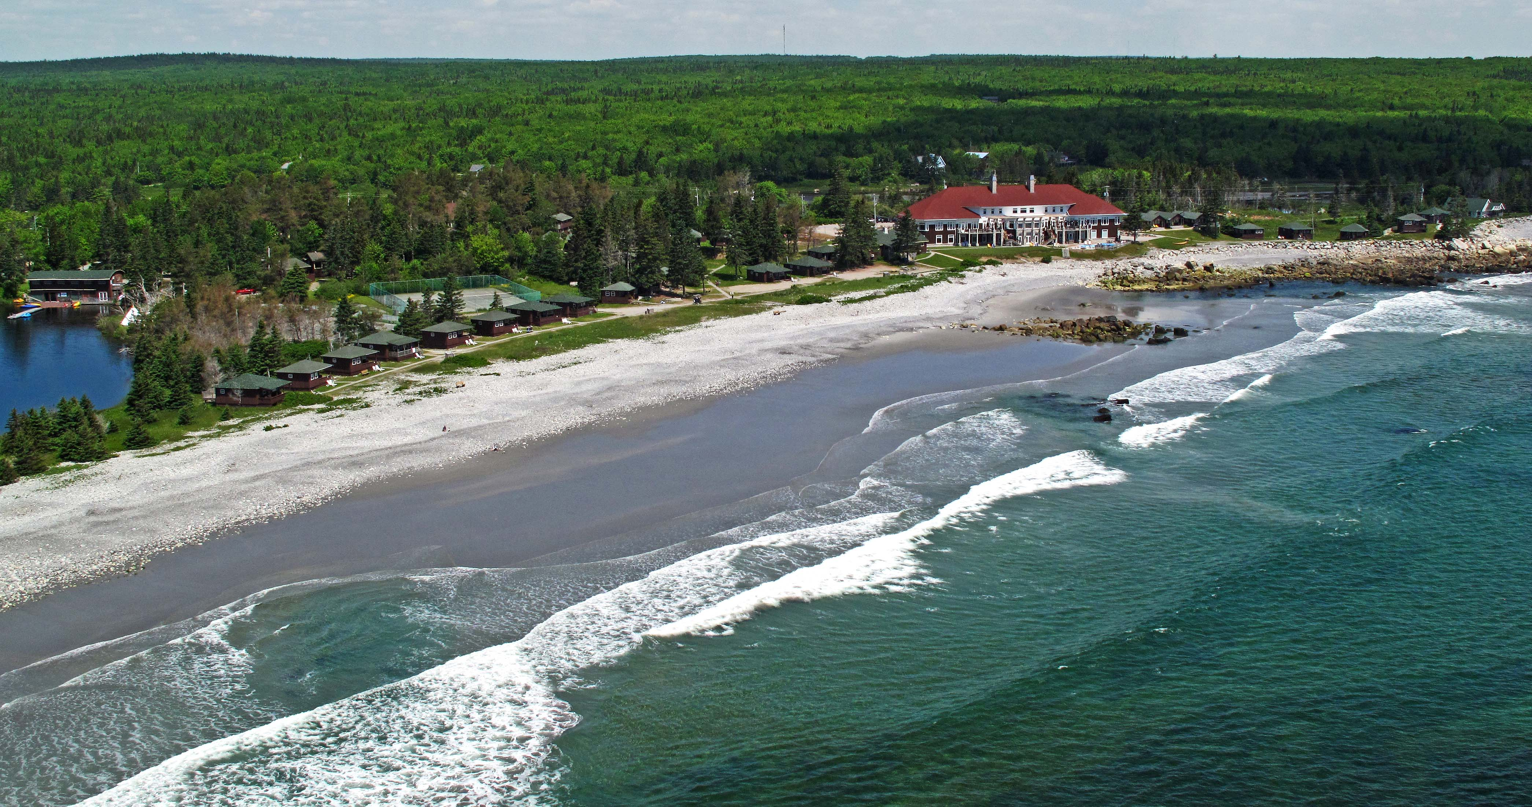
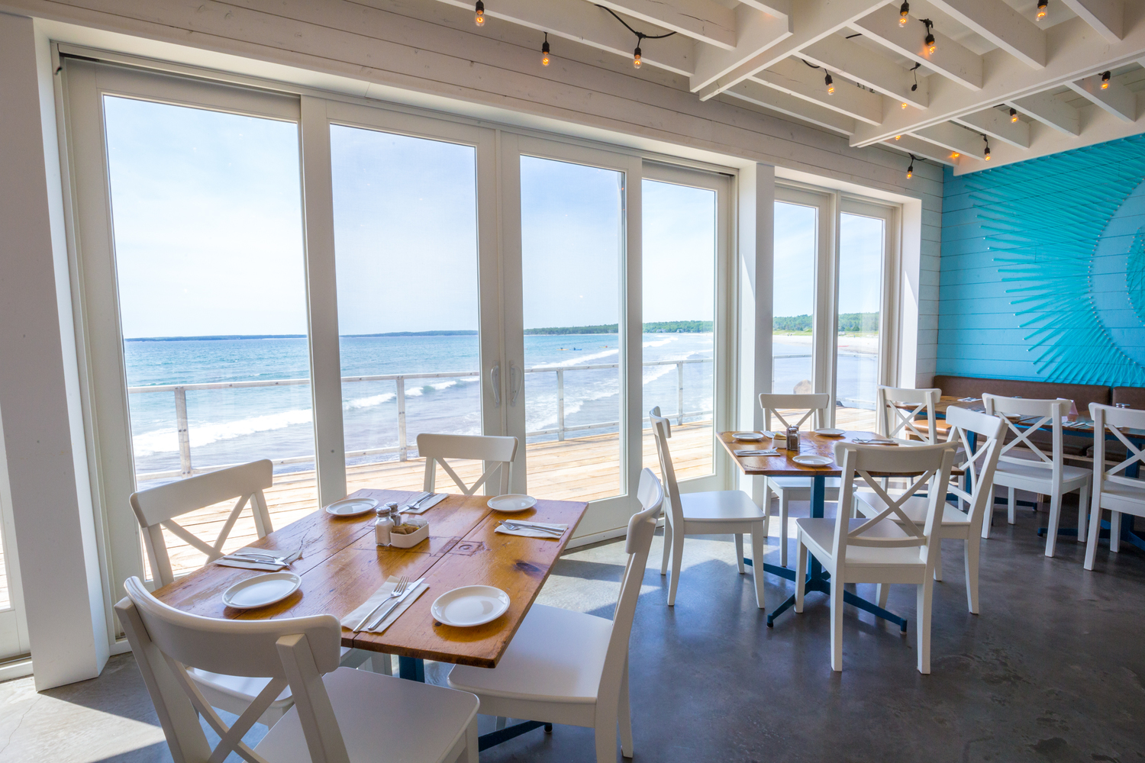
75 White Point Beach Resort Road – Hunts Point
902-354-2711
www.whitepoint.com
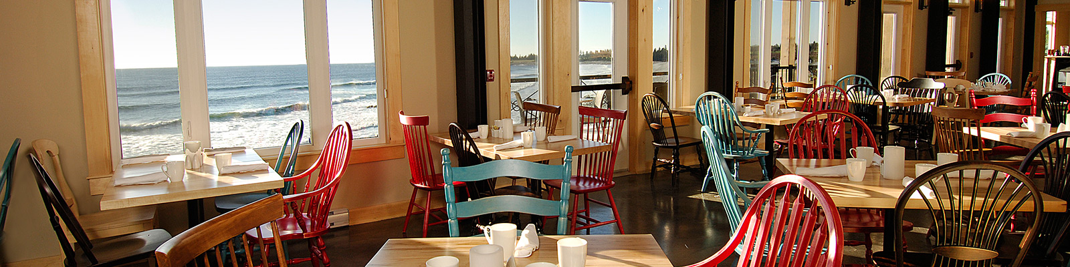
Fine Dining, Casual, Licensed, Gluten Free
Seascape Restaurant
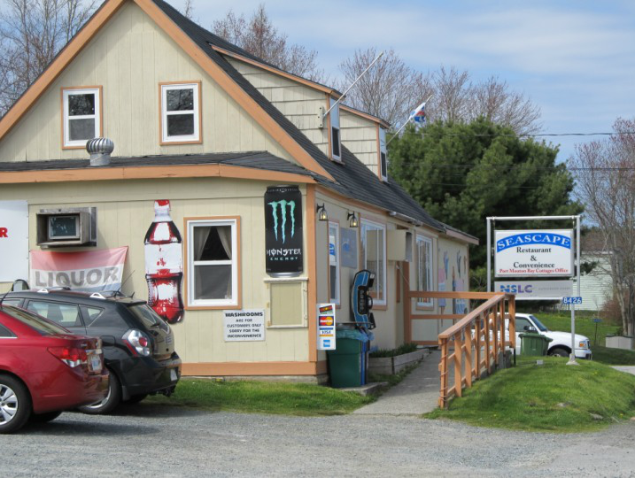
8426 Highway #3, (Lighthouse Route) Port Mouton
902-683-2626
www.cottagesinnovascotia.com
Licensed, Casual, Seasonal, Seafood

Seaside Seafoods
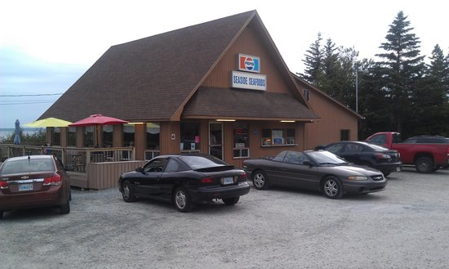
6943 Highway #3, Hunts Point
902-683-2618
www.seasideseafoods.ca
Casual, Seasonal, Seafood

The Port Grocer
1615 Port Medway Road, Port Medway – 902-677-2884
(Exit #17A off Highway #103)
www.theportgrocer.ca
Casual, Café
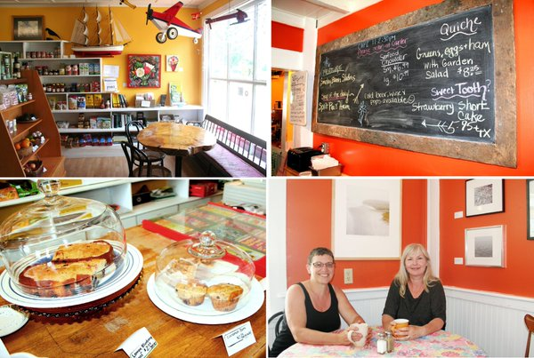
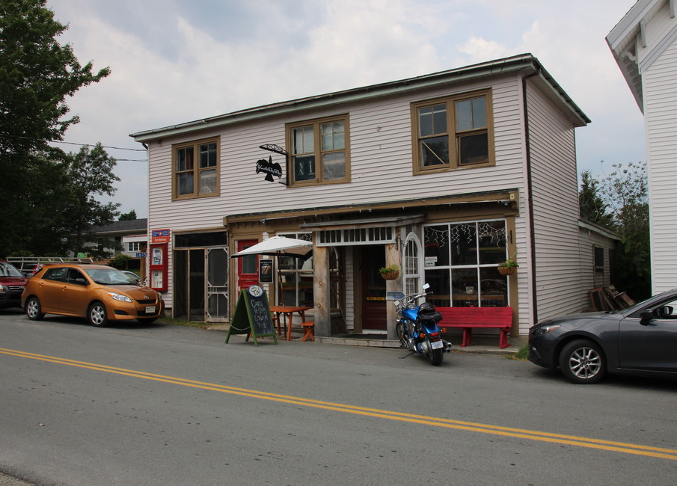
The Riverbank General Store & Restaurant
8 Medway River Road
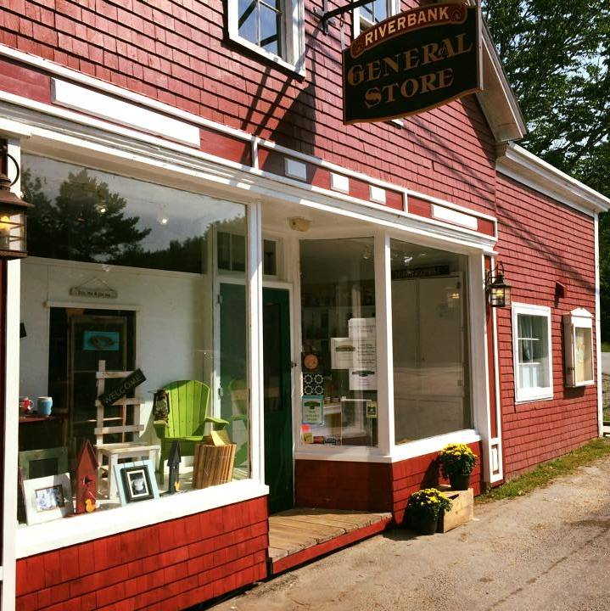
Exit #17A off Highway #103
Mill Village – 902-677-2013
